ASSIGNMENT 2

Name: Khushi Sharma
Roll No: 2301410007
Course: BTech CSE (cyber
security)

Problem Statement:
Modern operating systems are responsible for initializing system components, creating processes, managing execution, and gracefully shutting down. This lab aims to simulate these core concepts using Python, helping students visualize how processes are handled at the OS level. The focus is on creating a simplified startup mechanism that spawns multiple processes and logs their lifecycle using the multiprocessing and logging modules. This hands-on simulation enhances conceptual clarity and promotes coding proficiency in scripting real-world OS behavior.
Sub-Task 1: Initialize the logging configuration

CODE

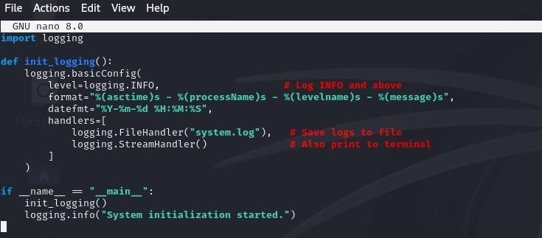
OUTPUT
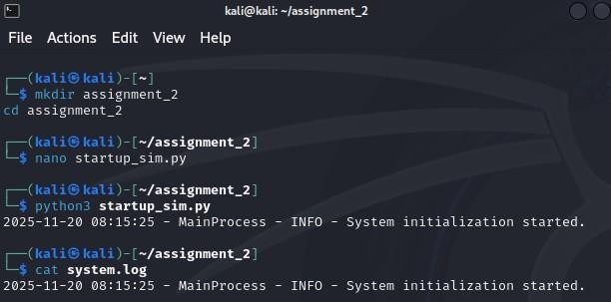
Sub-Task 2: Define a function that simulates a process task (e.g., sleep for 2 seconds).

CODE

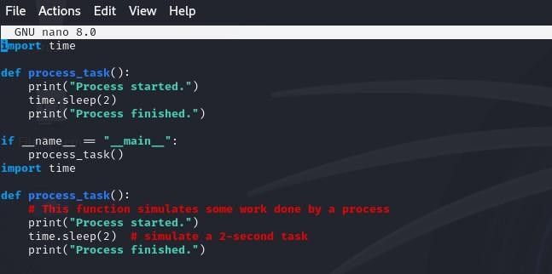

OUTPUT

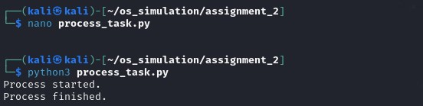
Sub-Task 3: Create at least two processes and start them concurrently.

CODE

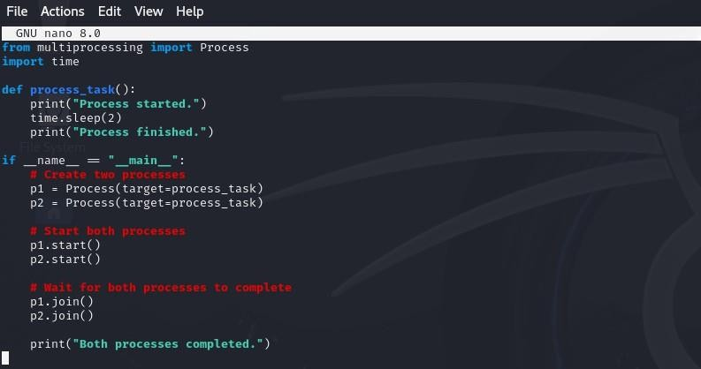

OUTPUT

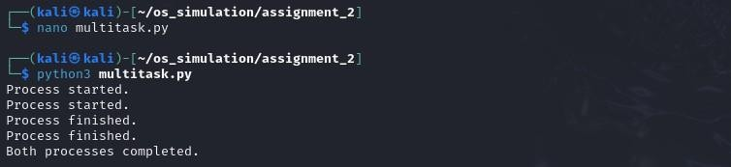
Sub-Task 4: Ensure proper termination and joining of processes, and verify the output in the log file.

CODE
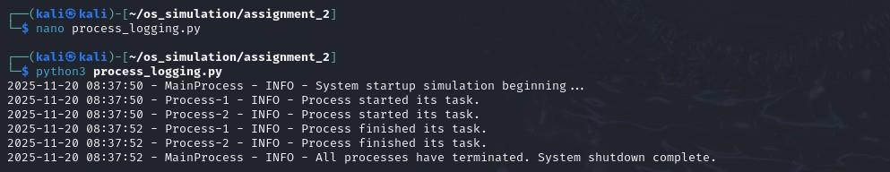
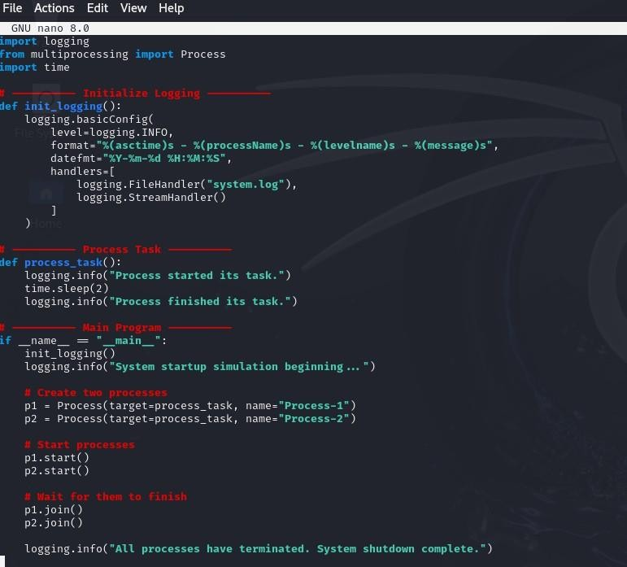

OUTPUT

